**PRACTICAL 6 : Calculate Distance**

**Aim :** To measure distance using an ultrasonic sensor and display the result.

**Overview :**

This project involves using an ultrasonic sensor to measure the distance of an object from the sensor. The measured distance is displayed on a serial monitor or LCD. This practical introduces the concept of using sound waves for distance measurement and helps in understanding sensor-based automation.

**Materials Required :**

* Arduino Uno R3
* 1 x 1 kΩ Resistor
* LCD 16x2
* Ultrasonic Distance Sensor (4-pin)
* Jumper Wires
* Arduino IDE (Installed on your Computer)

**Circuit Connection and Steps :**

1. **Connect the Ultrasonic Sensor (HC-SR04) :**
   * VCC → 5V, GND → GND
   * Trig → D9, Echo → D10 (Arduino).
2. **Connect the 16x2 LCD Display:**
   * RS → D7, E → D8, D4-D7 → D4-D7 (Arduino).
   * VSS, RW, K → GND, VDD, A → 5V.
   * V0 → Potentiometer (Middle Pin) for contrast control.
3. **Set up the Arduino environment :**
   * Open **Arduino IDE**, select the correct **board** and **port** under "Tools".

**Circuit Diagram :**

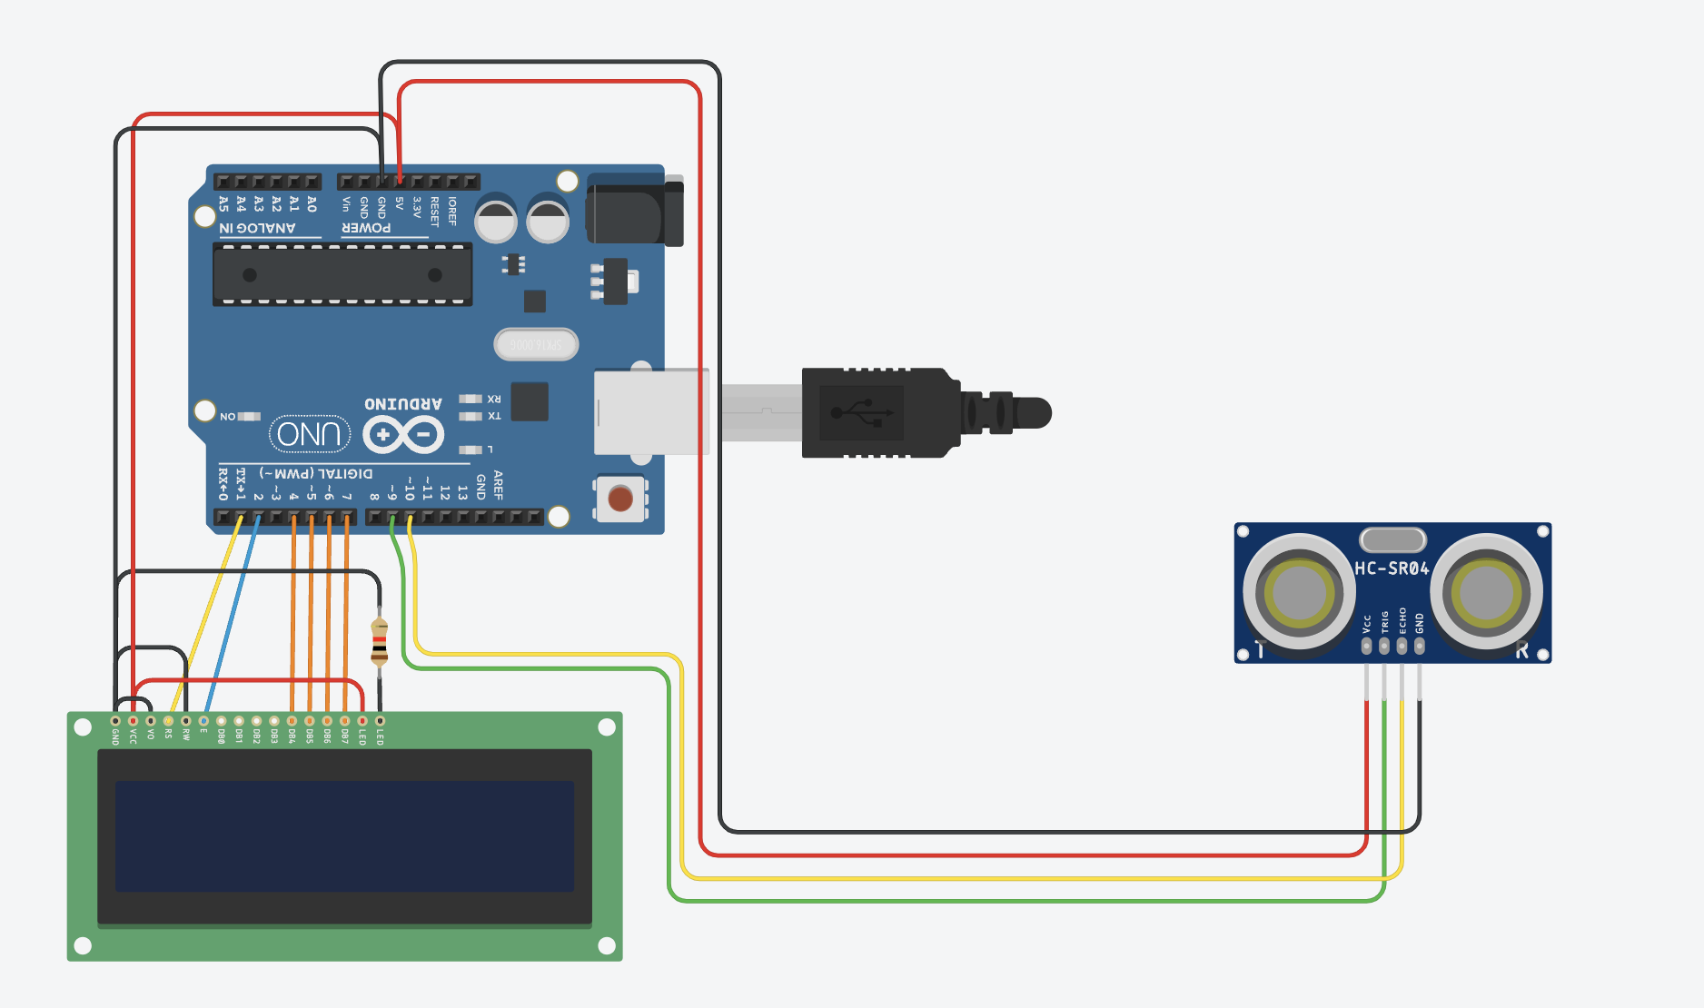

**Schematic Diagram :**

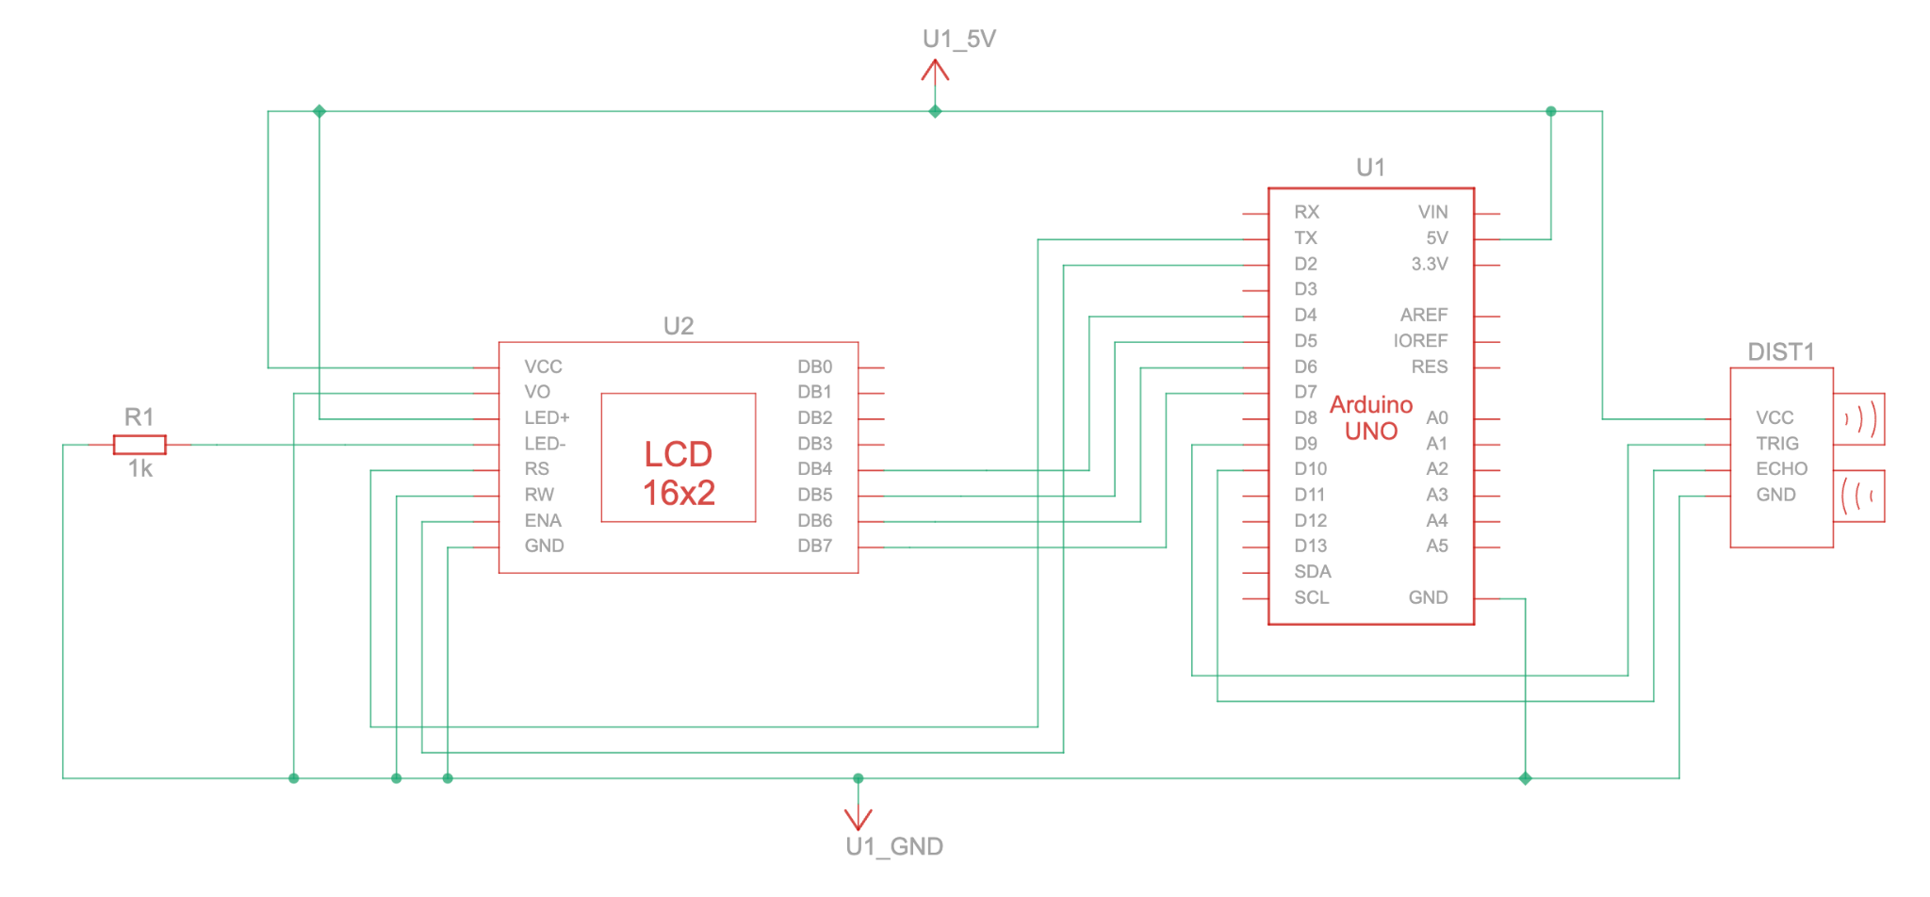

**Code :**

#include <LiquidCrystal.h> // includes the LiquidCrystal Library

LiquidCrystal lcd(1, 2, 4, 5, 6, 7); // Creates an LCD object. Parameters: (rs, enable, d4, d5, d6, d7)

const int trigPin = 9;

const int echoPin = 10;

long duration;

int distanceCm, distanceInch;

void setup() {

lcd.begin(16,2); // Initializes the interface to the LCD screen and specifies the dimensions (width and height) of the display

pinMode(trigPin, OUTPUT);

pinMode(echoPin, INPUT);

}

void loop() {

digitalWrite(trigPin, LOW);

delayMicroseconds(2);

digitalWrite(trigPin, HIGH);

delayMicroseconds(10);

digitalWrite(trigPin, LOW);

duration = pulseIn(echoPin, HIGH);

distanceCm= duration*0.034/2;

distanceInch = duration*0.0133/2;

lcd.setCursor(0,0); // Sets the location at which subsequent text written to the LCD will be displayed

lcd.print("Distance: "); // Prints string "Distance" on the LCD

lcd.print(distanceCm); // Prints the distance value from the sensor

lcd.print(" cm");

delay(10);

lcd.setCursor(0,1);

lcd.print("Distance: ");

lcd.print(distanceInch);

lcd.print(" inch");

delay(10);

}

**Results :**

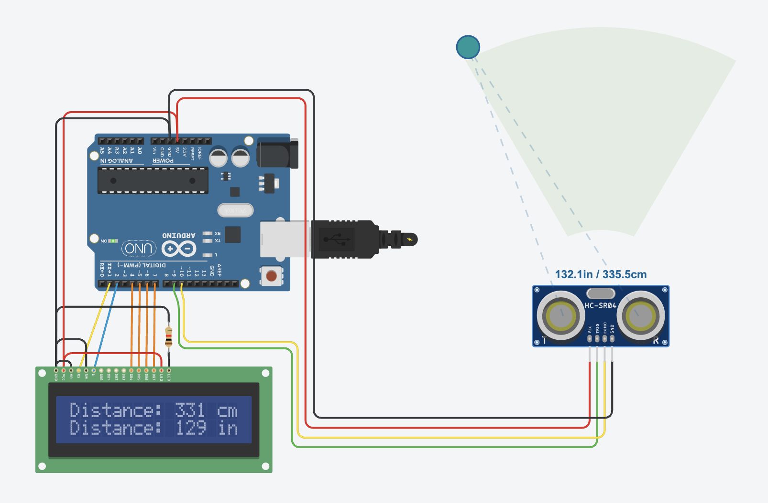 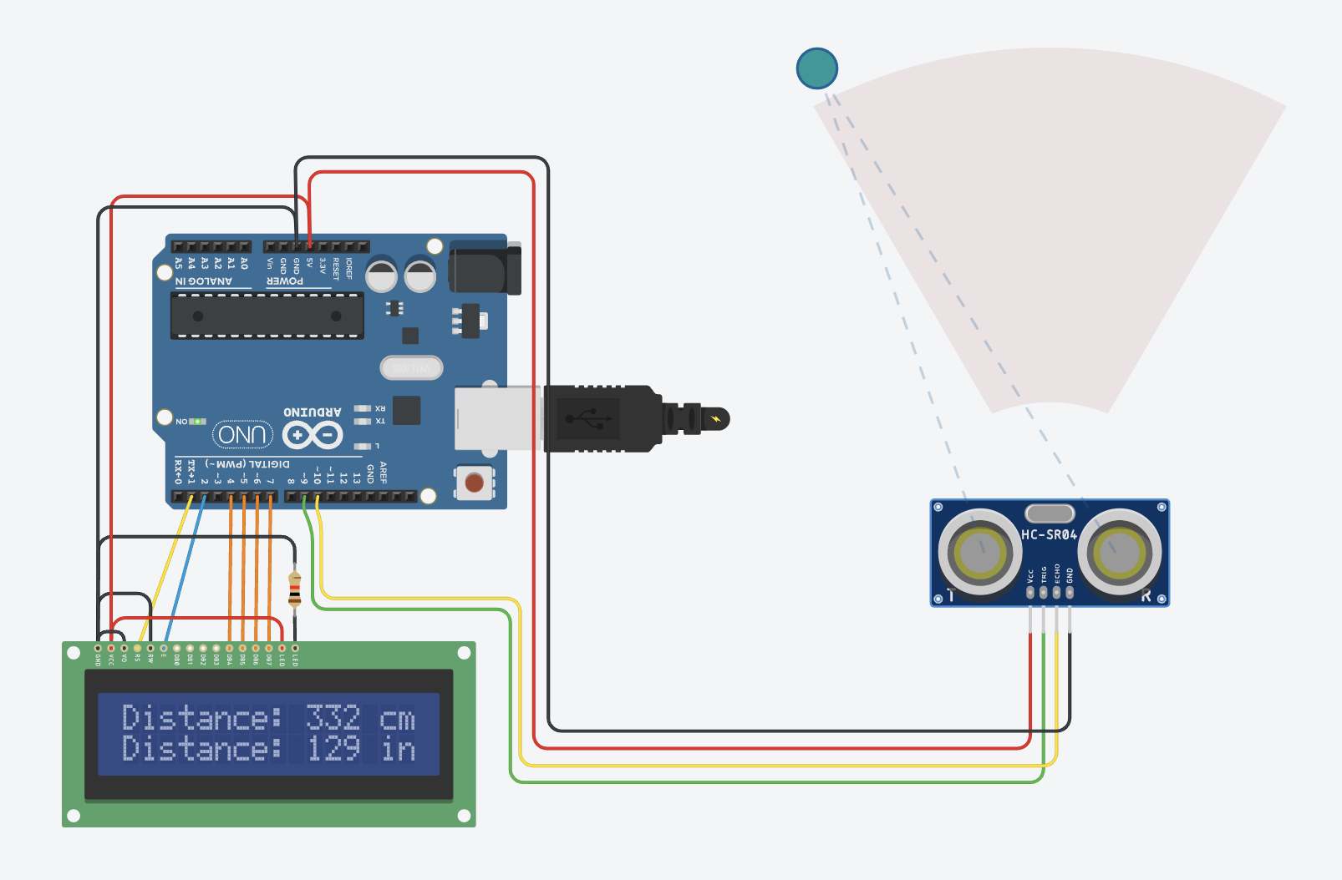

**Conclusion :**

The Distance Calculation project successfully measures and displays distance using an ultrasonic sensor. It introduces the concept of sound wave-based sensing and real-time measurement. This project forms the basis for applications like smart parking systems, automated doors and obstacle detection.